1. | Describe a food you enjoy eating.  You should say:  • how often you eat it,  • what ingredients are used,  • how you prepare it,  • explain why you enjoy it.
 | Sophie’s favourite food is chicken salad. She should write a paragraph. Which one is WRONG according to the card?
A) | I usually prefer it twice a week at lunch.
B) | The food I am in the mood for now is pasta.
C) | Chicken, tomatoes, red onion, pepper, salt, oil.
D) | I really like it because it is very healthy.

2. | Secretary: Hello, this is the marketing department. How can I help?  Mr. Johnson: Could I speak to Rosa Wilson, please?  Secretary: Who’s calling please?  Mr. Johnson: It’s Max Johnson here.  Secretary: Hang on a minute. …………………………?  Mr. Johnson: I’m sorry to hear that. Could you tell her to call me back today?
 | According to dialogue, which one DOESN’T complete the dialogue?
A) | I’m afraid she isn’t available at the moment.
B) | She has gone out. She will be back at two p.m.
C) | I will try to connect you, Mr. Johnson.
D) | She is at the meeting. May I take a message?

3. | Student: ----  Teacher: The Internet is full of websites for practising and learning English. The Internet gives you amazing opportunities to find resources for practising your language with lots of online grammar exercises, reading, writing and listening activities, and speaking games.
 | Which one CAN be student’s question for the teacher’s answer?
A) | How do you get an English account to learn English?
B) | How often do you use the Internet to practise English?
C) | Do you follow any bloggers or vloggers?
D) | What are some ways to learn English on the Internet?

4. | Cappadocia is a famous tourist attraction in Turkey. (I) Visitors can see the famous fairy chimneys. (II) They are the natural rock formations in here. (III) They can also take a hot air balloon tour with the amazing city view. (IV) And they can go horse riding or hike in the beautiful nature here.
 | Which one is ODD according to the text?
 | A) I B) II C) III D) IV

5. | I prefer going to historical places on my holidays because I love historic and ancient sites. (I) Machu Picchu in Peru is my favourite. (II)It’s an ancient Incan city. (III) Inca's civilization is an ancient empire. (IV) It’s about 2400 meters above sea level.
 | Which one is ODD according to the text?
 | A) I B) II C) III D) IV

6. | I have been abroad for two months. I have flown on a plane to Madrid. I have stayed at a bed and breakfast hotel at the seaside. The place is very nice. And the weather is just perfect. I really love here.
 | Which one ISN’T mentioned in the text?
A) | Cuisine | B) | Location
C) | Transportation | D) | Accommodation

7. | İstanbul is one of the world's great metropolises. It’s on both Europe and Asia continents. It’s founded around 1000 BC. It was Byzantine Empire's great capital of Constantinople until Fatih Sultan Mehmet conquered it.
 | Which headline is RELATED to the text?
A) | Don’t Live Without
B) | It’s Location and History
C) | What to Buy
D) | Climate

8. | Ecotourism is very popular nowadays. It wants to reduce of the negative effects of tourism on the environment and local people. For example, tourist shouldn’t damage environment and should ask local people’s opinion when they need. It encourages the tourists to think about what they do when they visit a place.
 | According to the ecotourism, people SHOULDN’T ---
A) | respect for local people
B) | obey cultural rules
C) | protect natural heritage
D) | be selfish about culture

9.
Tina made a ‘Have you ever ... ?’ survey to her friends. In her class there are ten girls and ten boys. According to the graphic, which one is WRONG?

A) | All boys have done an extreme sport.
B) | Most students have tried different dishes.
C) | Boys haven’t used air ways yet.
D) | A few girls have gone to a foreign country.

10. | Brian: I love wildlife. This summer I would rather visit Costa Rica. I can see various types of wild animals there.  Suzan: I’d rather go to Fethiye for my vacation. Because I want to swim, go scuba diving and ride on Jet Ski.  Paul: This summer I would rather go on vacation to Berlin. I prefer bus tours and visiting historical locations.  ●sightseeing ●cruise ●seaside ●camping ●safari
 | What type of vacation do they prefer? There are two extra words.
a. Brian prefers ........................................................................ holiday.
b. Suzan prefers ....................................................................... holiday.
c. Paul prefers .......................................................................... holiday.

11. | ● visitors ● attractions  ● complex ● built  ● authentic ● located  ● waterways
 | Complete the text with the words below. There are two extra words.
 | Prambanan is a great Hindu temple a.----------- in Indonesia. It is b.---------- approximately 18 kilometres east of Yogyakarta in Central Java. It is Indonesia's largest Hindu site and one of Southeast Asia's major c.----------. There are 224 temples in it. Indians d.----------- it in the 9th century. Its central building is 47 m high. Prambanan is in UNESCO World Heritage List and it attracts many e.---------- from across the world.

12. | ● Great Wall of China is the longest and oldest construction project in the history.  ● The local people showed me great hospitality.  ● This holiday has more recreational activities and sports than others.  ● Frank stayed at an all-inclusive hotel last summer.  ● Grand Canal is one of the oldest artificial waterways in the world.  ● Georgia Aquarium contains about 100.00 fish, and there are more than 500 species.
 | Match the words in sentences with their definitions. There are two extra words.
a. ____________: It includes most meals, drinks, and activities in the overall price.
b. ____________: It is the building of things such as houses, factories, roads, and bridges.
c. ____________: These are things people do for fun and enjoyment like playing games or participating in clubs.
d. ____________: It is kindness and friendly behaviour to guests or visitors.

(Answer the questions 13 – 14 according to the dialogue.)

13. | Jane: Have you ever been abroad?  Pınar: Yes, I have been to Italy. It was fascinating.  Jane: That’s good. When did you go there?  Pınar: I went there last year. Italy is a home of the greatest number of UNESCO World Heritage Sites in the world.  Jane: Really? What are the main tourist attractions in Italy?  Pınar: It’s hard to make a list. It has great cities of art and different architecture. And there are also beautiful coasts, alpine lakes and mountains in Italy.  Jane: I love historic sites. So I would rather visit Italy for my summer holiday.  Pınar: Nice, but I should warn you about Italy. I don’t prefer visiting there for this summer.  Jane: Why? What’s the matter?  Pınar: Coronavirus Disease is common in Italy. You shouldn’t go abroad, especially Italy this summer.
 | Answer the questions.
a. What kind of tourist attractions does Italy have?
.................................................................................................................................................
b. Why does Pınar warn Jane about Italy?
.................................................................................................................................................
c. What is Pınar’s opinion about Italy trip?
.................................................................................................................................................
d. Does Jane have a plan about her holiday?
.................................................................................................................................................

14. | Write “True” or “False”. If the sentence is false, correct and rewrite it.
a. The Italy trip of Pınar was extremely interesting.
.................................................................................................................................................
b. There is only fantastic beaches and natural beauties in Italy.
.................................................................................................................................................
c. Jane prefers modern cities to ancient ones for her holiday.
.................................................................................................................................................
d. Italy has rich attractions for tourists that visit there for holiday.
.................................................................................................................................................

15. | Write the name of the countries on the postcard. Use the Internet if needed.
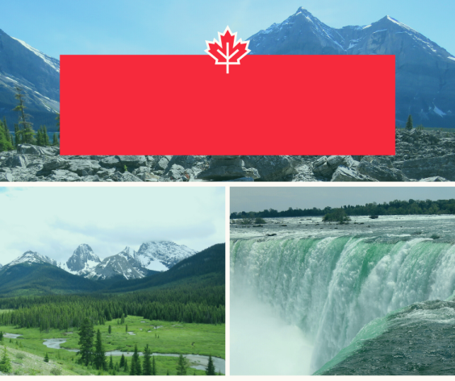 | a. It is the second largest country in the world. It has beautiful landscapes and unique sites for travellers to explore. It has culturally rich cities with natural wonders.  Niagara Falls, Toronto, Ottawa, Montreal, and Quebec City are some of the most popular destinations.
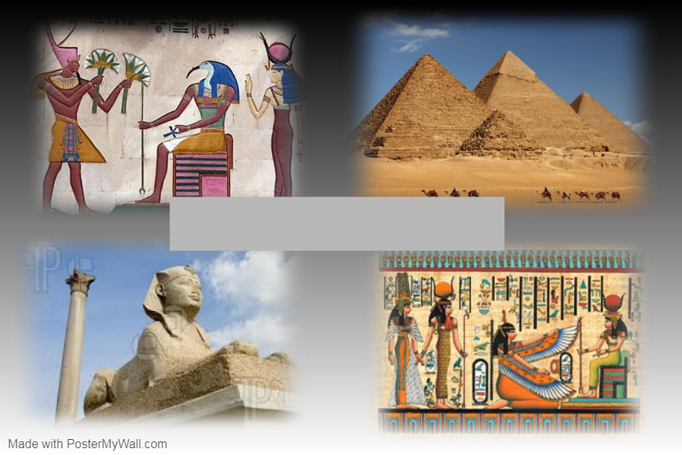 | b. It is famous for its ancient civilization and some of the world’s most famous monuments like the Giza pyramids, the Great Sphinx and the ancient temples of Luxor.  Great monuments along the Nile, snorkelling and diving along the Red Sea coast and camel trips into the mountains of Sinai are other tourist attractions in this country.

